**Strategic Marketing Simulator Website Mockup**

The purpose of this mockup is to give the project manager an opportunity to give feedback to the develop team and make sure that they are on the right track.

Disclaimer: The website will not look like this at all. This is basically a proof of concept.

**User forms**

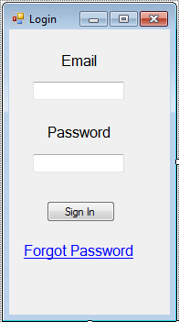

Login: User logs in using an account already created by the admin/instructor

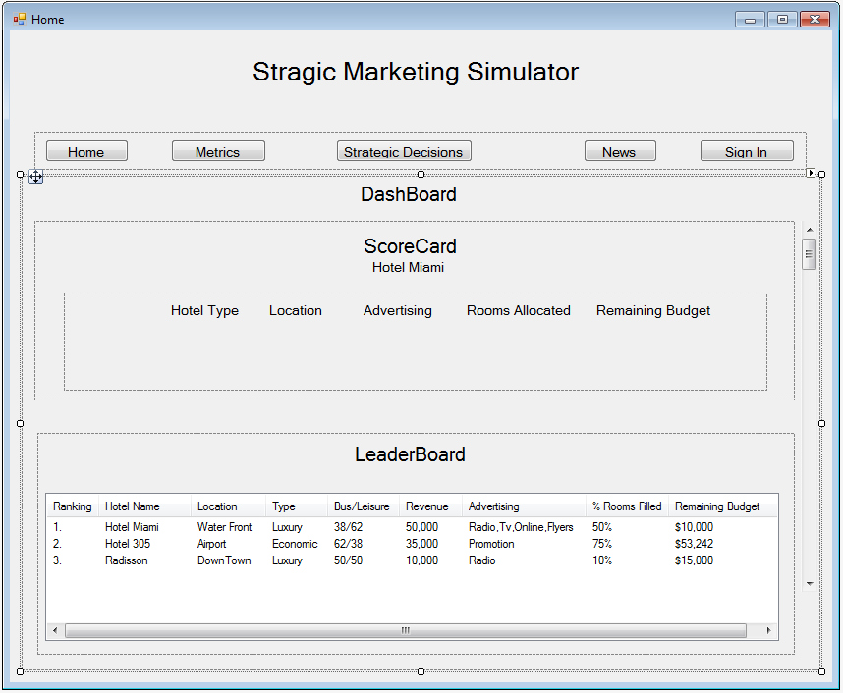

Home page: User can view dashboard and toolbar (graphs would be below the leaderboard).

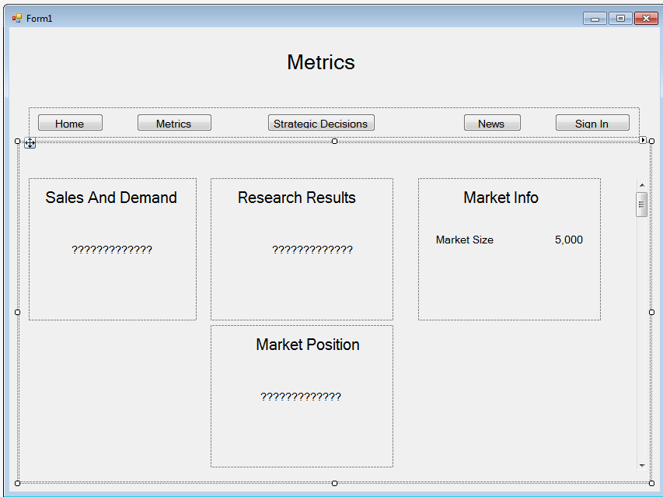

Metrics Page: User can view in-depth details about market of the current period

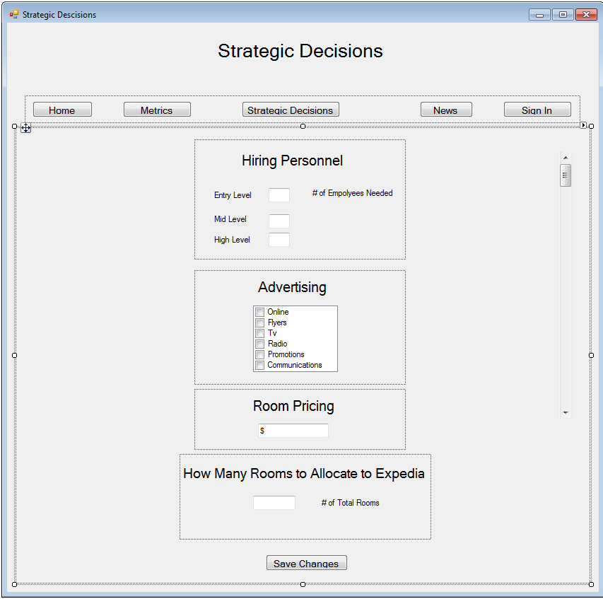

Strategic Decisions Page: User can assign marketing personnel, advertising media, room pricing, and third party vendors.

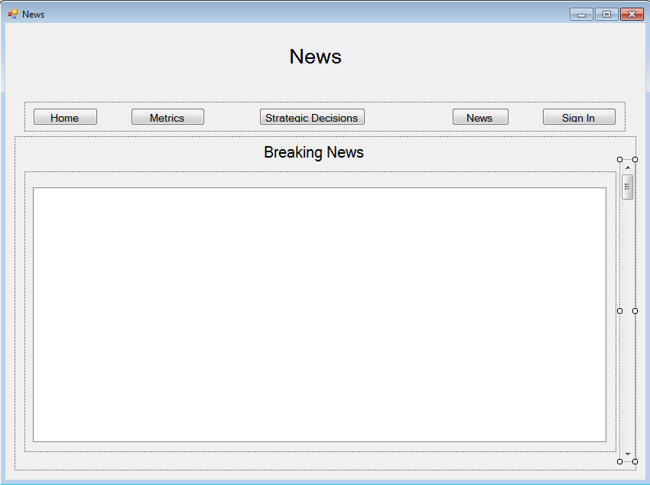

News Page: User can read a realistic news article and adjust their strategic decisions based on the contents of the article.

Admin Forms

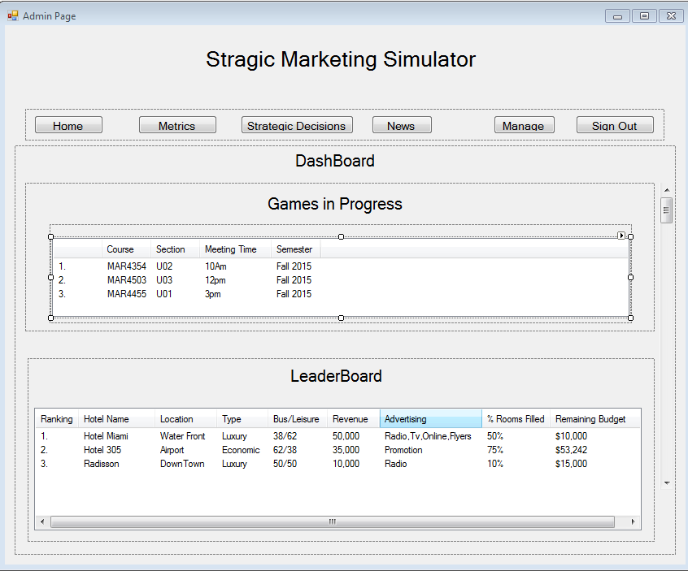

Admin Home Page: Admin can select a game in the dashboard and view the leaderboard for that game. Admin can also navigate to other admin pages via the toolbar above the dashboard.

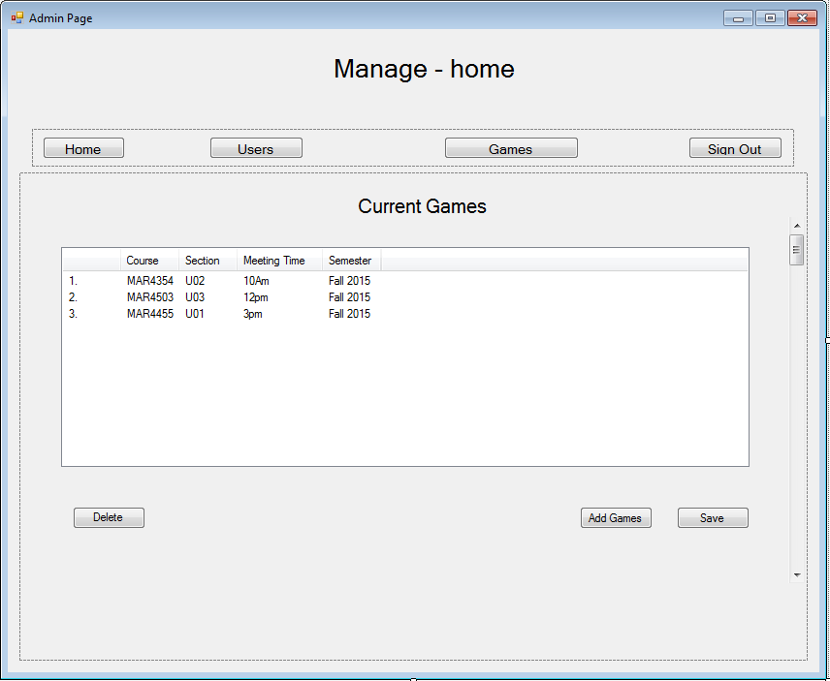

Admin Managing Page: Admin can select an active game to manage or delete. Admin can also create a new game. Click on game to go to next slide below:

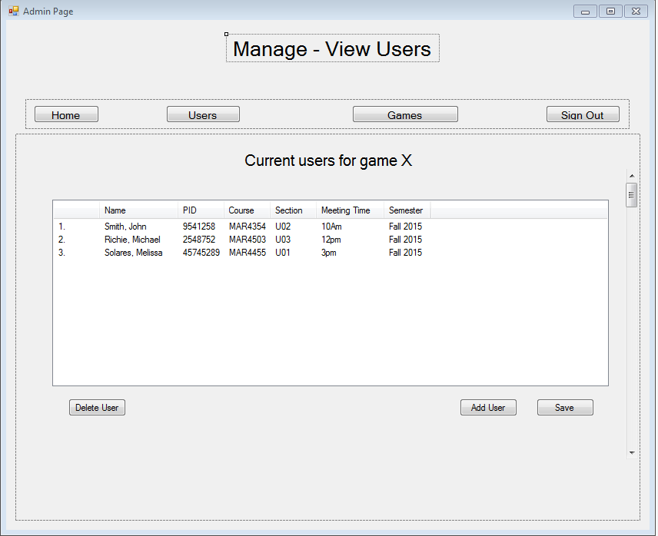

Admin view all the users associated with a game selected from the games list on the manage/games page

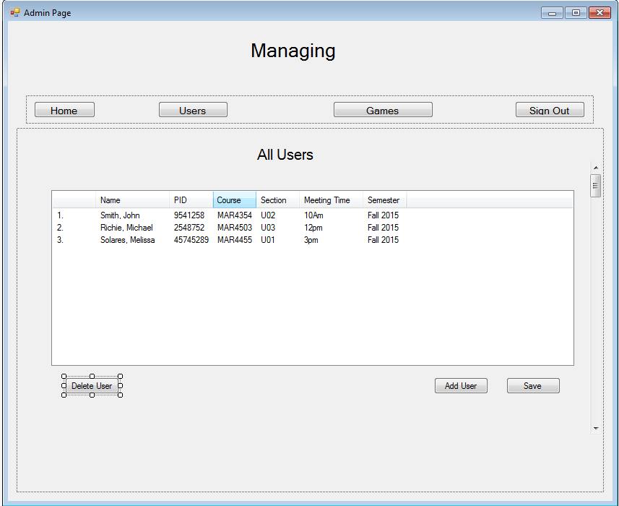

Admin can view all users by clicking “users” from the admin toolbar of manage page

Admin User List Page: Admin can view all users in a selected game, including bots.

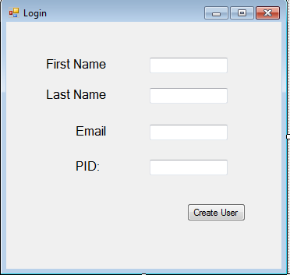

Admin Create User Window: Admin fills out required information to add a new user to a game.

(Needed: Checkbox to create a user that will be a bot)

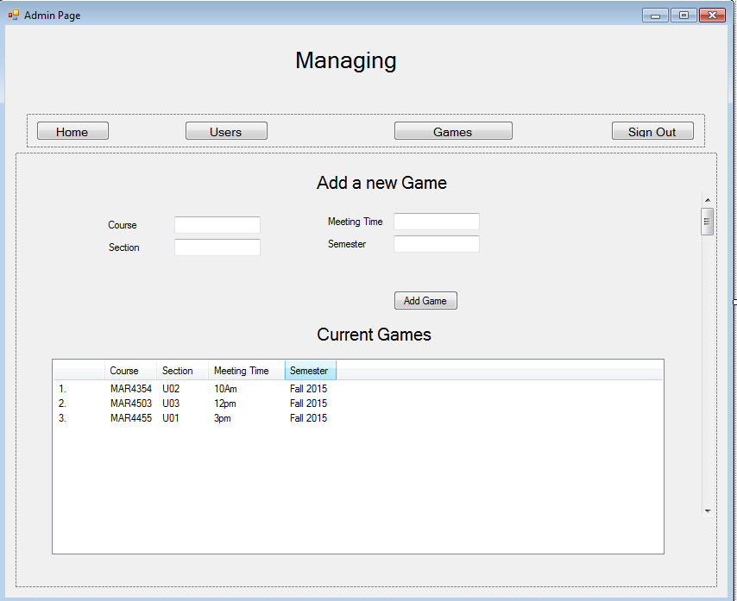

Admin Create a new Game Window: Admin fills out the required information to create a new game

(Needed: textbox(s) for assigning default budget and other in-game variables)